3

Vocabulary Development

The Foundation for Reading in the Content Areas

Selecting Words to Teach

The selection of words to preteach was based on research by Beck and colleagues (Beck, McKeown, & Kucan, 2002) as well as on the work of the Vocabulary Improvement Project (Carlo et al., 2005), the BCIRC study (Calderon, Hertz-Lazarowit z & Slavin, 1998), and the Transition from Spanish into English study (Calderon et al., 2005). Beck and colleagues have developed a systematic method of selecting vocabulary to teach to students. Words are grouped into three tiers, and words in Tier 2 are those targeted for instruction. Tier words include
11) words that have importance and utility (they are characteristic of mature language users and appear frequently across a variety of domains), (2) words that have instructional potential (words that can be worked with in a variety of ways so that students can build rich representations of them and their connections to other words and concepts, and (3) words for which students already have conceptual understanding (words for which students understand the general concept but provide precision and specificity in describing the concept). Tier 1 words are words English-speaking students already

29

30

know and Tier 3 words are words students are unlikely to know but are also words that are not frequently used across a variety of domains. The approach to teaching the words in each tier is predicated on four dimensions: nature of the word (is it concrete or can it be demonstrated), its cognate status, depth of word meaning, and utility (Beck, McKeown, & Kucan, 2002) .

Tier 1 Words for ELLs. We take it for granted that native English speakers know most Tier 1 words, but this is not the case for English language learners. Many Tier 1 words may be unknown to English language learners and key to the comprehension of a written passage. For Tier 1 words, ELLs typically know the concept in their primary language but not the label in English. For example, a Tier 1 word might be butterfly. This is a word that English language learners may not know, but it can be easily taught during a text presentation and discussion by pointing to a picture of a butterfly and asking the students to say it three times. Another Tier 1 word might be bug. Words like bug (insect) or march (move like a soldier) may be easily instructed during text discussion by pointing to a picture of a bug or marching in place, but because the words are polysemous (have multiple meanings) , they merit further instruction, and this can be accomplished in oral language activities that follow the text discussion (Calderon et al., 2005).

Words that Ells need for everyday speech, for academic conversations and explanations, and for scaffolding more complicated text

- Basic words for which students know concept and label in the primary language but need English label (e.g.. find, search, guest, tooth, answer).
- Simple idioms are basic expressions that Ells are unlikely to know (e.g., make up your mind; let's hit the books; once upon a time; sit up).
- Connectors (e.g.. so, if, then, however, finally) .

There are some Tier 1 words that cannot be demonstrated and are not polysemous, but students will need to know them also (e.g., uncle). A simple explanation of the word's meaning during the story reading will suffice, or if the teacher and students are bilingual, a translation is

sufficient. Simple idioms and everyday expressions (e.g., make up your mind; let's hit the books; once upon a time) are also Tier 1 words, and teachers will need to explain the word meaning to students. Some Tier 1 words are cognates with a language like Spanish (family/familia; preparation/preparación); the cognates in this category consist of words that are high-frequency words in Spanish and English; they do not require substantial instruction because students know the word mean­ ings in Spanish. (The teacher merely states the English cognate, and students provide the Spanish cognate, or the teacher provides the English cognate, and the students say both the English word and Spanish cognate.) False cognates also need to be pointed out by the teacher and the correct translation given (rope/ropa, soap/sopa). The word assist is usually translated as asistir, but the correct translation is atender, and attend means asistir. Yet asistencia means assistance, but attendance is not atendencia (this word does not exist), and it is also correct to say asistencia. Confusing enough? We call these polysemous cognates. They can be either true or false cognates, depending on the context.

Tier 2 Words for ELLs . These are words that have importance and utility because they are in grade-level texts. Unfortunately, these do not receive as much attention as Tier 1 and Tier 3 words because ESL teachers typically teach Tier 1, and mainstream teachers focus on Tier 3 (content key) words. It's our hypothesis that the lack of explicit instruction of Tier 2 words is what keeps ELLs from moving on to Tier 3 words and thus developing reading comprehension of content texts.
Tier 2 words can be worked with in a variety of ways so students can build rich representations of them and make connections to con­ tent words and concepts. These are also words for which students understand the general concept but need to learn to provide precision and specificity in describing the concept.
Some Tier 2 words are those tiny words that make comprehension difficult for ELLs, such as so, at, into, within, by, if, then. Others are sometimes clustered to connote certain usage, constructs, or "ways of talking about school stuff," as one teacher alls them. They are also called transition words. These are helpful to compare and contrast, to describe or give examples. The box below has some examples.
In addition, many Tier 2 words are cognates (in this Tier they are
high-frequency words in Spanish and low-frequency words in English), and children whose first language shares cognates with English will have a head start with these words. Words in Spanish parallel words in English, such as digestion/digestion, coincidence/ coincidencia, industrious/industrioso , and fortunate/afortunado: Many

32 ...Teaching Reading to English Language Learners, Grades 6-12

Spanish speakers will know both the concept and an approximation of the label in English. If they don't know the meaning in either language, both can be taught together. This category also includes less common idioms and metaphors that are key to making inferences.

Some criteria for identifying Tier 2 words:

- Importance and utility: words characteristic of mature language users appear frequent ly across a variety of domains (e.g., power, cell, radical, right, leg, tree, prime , imaginary, round, simple, expression, dependent).
- Conceptual understanding: words for which students understand the general concept but provide precision and specificity in describing the concept.

Cause and Effect-because, due to, as a result, since, for this reason, therefore, in order to, so that, thus ...

Contrast-or, but, although, however, in contrast, nevertheless, on the other hand, while ...

Addition or comparison-and, also, as well as, in addition, likewise,
moreover, by the way ...

Giving examples-for example, for instance, in particular, such as . ..

- Polysemous words: These are some of the most troublesome words for Ells. It is important to teach words like trunk because Ells typically know only one meaning, and that meaning may not be relevant to the context in which it is found. It is also necessary for Ells to learn simple words such as set, table, ring, bad, and slip and how they are used in two, three or more contexts. The words listed in the first bullet above (e.g., power, cell, line, run, root) are also polysemous and are used differently across the content areas.

Tier 3 Words for ELLs. Many Tier 3 words are cognates because they are specific to certain content areas (e.g., osmosis, photosynthesis, peninsula). However, students may not know the actual concept or process; therefore they need to be pretaught along with the concept. Sometimes, the students may have partial knowledge of a concept or word (fractions) and need details or specificity. If possible, Tier 3

)

words that are not demonstrable or are cognates can be translated or briefly explained in the first language. In this category we also include others that may not be essential to understanding the main points of the text. These can be explained briefly to the students, but they don't have to master these words.

Low-frequency words in English.
These are the words that are limited to specific domains, such as social studies, math, language arts, or science. Although they are low-frequency words, they are very important for understanding content. For instance: lathe, isotope, peninsula, osmosis, polysemy, hyperbole [all cognates].

- Cognates are words in two or more languages that sound almost the same or are spelled the same (for instance in English, Spanish, and French we find words such as telephone/teléfono/téléphone; the radio, el radio, le radio; education/la educación/l’éducation).
- Literate Spanish speakers have a great advantage over monolingual English speakers with Tier 3 words because many cognates are high­ frequency words in Spanish but low-frequency words in English (e.g., coincidence/ coincidencia, absurd/ absurdo, concentrate/ concéntrate,

and fortunate / afortunado.
- However, some students will need to learn the concept or specificity
for some cognates (e.g., democracy/democracia).
- Polysemous cognates and false cognates (e.g., mass/masa or misa; attend a meeting/asistir a una junta; assist someone / atender a alguien/asistencia; round/redondo/vuelta round off/redondear).

Of course cognates and polysemous words can be either Tier 1, 2, or 3. It depends on the difficulty of the word or the background knowledge of the student. By the same token, selecting words for the three tiers will also depend on the subject, grade level, and student background knowledge. There are no lists for Tiers 1, 2, and 3. Each classroom will be different. Each group of students will be different. Each will require an analysis of the words to be taught before, during, and after reading.
It is important to preselect words to teach before, during, and after
reading to focus on the most important concepts from the standards

34

.
and basic knowledge that will make a difference in the student's test
results. As the students delve into the text, there will be other words you might .not have even thought about. These can be collected and pretaught the following day, or they can be taught quickly without interrupting the reading too long. The following section describes ways teachers and students like to conduct word study activities in the context of learning content and preparing for exams.

-.

Preteaching Vocabulary

Preteaching vocabulary is critical to comprehension . Before students read a text or a teacher reads a text aloud to the students or a teacher lectures, it is vital to preteach 6 or 7 words that are key to compre­ hending that text or lecture. There may be many words ELLs do not know in each subject area. Therefore, the selection of those 6-7 words to preteach in all content classrooms needs special attention. Teachers can select 2 or 3 words from each tier each day, as the students progress through a textbook or combination of reading, discussions, lectures, summarizing of content.

Preteaching vocabulary is a seven-step process. It is different from the process used by Beck and colleagues because these steps integrate second-language strategies.

- The teacher says the word in English (and in the primary lan­
guage in bilingual classrooms).

- The teacher states the word in context from the text.

- The teacher provides a definition or key definitions from the dictionary (not the students-they may have partially correct or wrong definitions).

- The teacher provides another example of the word in a way
that clarifies the word's meaning (in student-friendly terms).

- The teacher asks students to repeat the word at least 3 times to build a phonological representation of the word.

- The teacher ensures 100% of the students become "engaged with the word" through oral language activities. The produc­ tion activity can be carried out with a partner. For instance, the

Vocabulary Development 35

teacher might say, "Tell your partner about a time you were mesmerized." After a minute of sharing with partners, the teacher asks two or three students to share what their partners said. "Turn to your partner" and "tell me what your partner said" ensure 100% production by all students because all are using the word at the same time and hearing it several times from others. When they have to report to the teacher what their partners said, they need to apply it again from a different ref­ erence point, a different context, using it with related words and phrases. This discourse sequence helps ELLs anchor their knowledge of the word. It helps non-ELLs achieve higher levels of specificity. It also develops listening and paraphrasing skills, third-person pronoun-verb agreement (My partner says...), and other grammatical structures.

- They say the word again or the whole sentence where it is found.

Here is an example of how teaching the word revolution might look through the seven steps:

l. Revolution. Say revolution 3 times with me.

- The text says: The revolution was set in motion with a sequence of actions from 1763 to 1783.

- The dictionary defines it as the overthrow of a government or social system with another taking its place. Another meaning I see here is "movement of a body, a star or planet in a circle." The revolution of the earth around the sun takes how long?

- My children love pizza. But, if I have to eat pizza again this weekend, I will start a revolution!

- Say revolution with me 3 times. ---
- What would make you start a revolution? Share with your
partner. (After 1 minute) What did your partner say?

- Let's say (or spell) the word.

100% Engagement. There are many other ways of getting students engaged with a word. It does not always have to be a "think-pair­ share" activity. Students can respond chorally or in popcorn style

36 Teaching Reading to English Language Learners. Grades 6-12

(students call out answers as they think of them), or by applause or
thumbs-up signals, as in the following examples.

l. Answer teacher questions by giving reasons or examples:

  - If you are walking into a dark room, you need to do it cautiously.
Why?
  - Using critical thinking skills while learning words. Selecting or making choices.

"'-...-.
Which of these things would be integers? Answer in a com-
plete sentence.
    - a positive number or a fraction?
    - a negative number or a decimal?
    - a zero or a percent?

  - Thinking about specificity when using adjectives, verbs, or
concepts.
    - Applaud if you hear an adjective:
      - affected
      - few
      - mainly
      - farther
    - Applaud if the name you hear belongs to a U.S. president:
      - James Monroe
      - Martin Sheen
      - Benjamin Franklin
      - Thomas Jefferson

When teachers use strategies such as these to preteach vocabulary, they are also teaching or reviewing other skills, concepts, and Ior metacognitive strategies. With the example of the word integer students need to listen carefully, compare two responses, and choose the most appropriate one. They have to think quickly, make inferences, and respond. The teacher can ask for complete sentence responses, where ELLs can practice answering long strands of discourse, scaffolded by the teacher's phrases. This ensures appropriate answers, the use of "would be" and other more sophisticated patterns. (A positive number would be an example of an integer.) Responding in complete sentences creates a sense of confidence and self-efficacy in the ELLs as their responses become more and more sophisticated.

Vocabulary Development 37

Developing vocabulary
Through Discourse Around Text

Vocabulary is also developed through ongoing dialogue between the teacher and students about the text during teacher and student read­ ing. Reading begins with the teacher reading aloud the first two para­ graphs or so of a text. During the read-aloud, the teacher uses different types of questions, stopping at specific intervals in the text to elicit dis­ cussion and teach more words "on the run." Different methods are used depending on the nature of the word (is it concrete, or can it be demonstrated?), its cognate status, depth of word meaning, and utility. Strategies for teaching English as a second language such as the fol­ lowing can be used to teach words on the run. The use of pantomime and gestures, showing pictures and real objects, and doing quick draws on the board can be used to quickly explain what a word means.
Questions can also help prompt students to talk about ideas using the target words. Questions have to be carefully crafted ahead of time. Some questions elicit one-word responses or are likely to elicit only sparse responses. There are also questions that help students move from using ju st pictures and background knowledge to more elabo­ rated responses tied to the text. Other questions call for more thinking and elaboration. The graph on page 38 is one example of a tool often distributed to the students for constructing and answering questions.

Oral Language Activities for Building Vocabulary

The language development activities that follow reading are based in large part on the words the story has provided. Different stories, chapters, texts lend themselves to different kinds of oral activities that help further language ease. Nevertheless, the key focus is on devel­ oping conceptual knowledge about the words and reinforcing labels for the word. The following examples focus on different syntactic and semantic features of English. ·--.... ... ....

How Students Learn and Remember Homonyms

Students can use Venn diagrams to compare and contrast words across subjects or to learn homonyms. Seeing how words are used across content areas helps them remember their multiple meanings. For example, students can place the words and provide a mini defin­ ition to words such as pi and pie .

AP PLYING BLOOM'S TAXONOMY OF COGNITIVE PROCESS-5
THINKING PROCESS | USEFUL VERBS | SAMPLE QUESTIONS STEMS | POTENTIAL ACTIVITIES AND PRODUCTS
s  y  NT HE  s  I  s | Create Invent Compose Predict Plan Construct Design  Imagine Improve Propose Devise Formulate | Can you design a...to...? What is a possible solution to...?  What would happen if...? If you had access to all  resources, how would you  deal with...  How would you devise your own way to...?  How many ways can you...? Can you create new and  Unusual uses for ...?  Can you develop a proposal  that would ...?  How would you compose a  song about...?  Can you write a new recipe for a tasty dish? | - Invent a machine to do a specific task.  - Design a building.  - Create a new product. Give it a name and plan a marketing campaign.  - Write about your feelings in relation to...  - Write a TV show, play puppet show, role play, song, or pantomime about...  - Design a record, book, or  magazine cover for ...  - Devise a way to...  - Create a language code.  - Sell an idea to a billionaire.  - Compose a rhythm or put new words to a known melody.

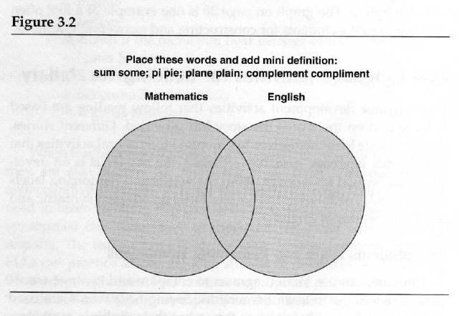

Graphic organizers are great tools for ELLs for organizing infor­ mation to be learned and also for using the new words in extended discourse through oral summaries or retell.

vocabulary Development 19

How Students Learn and Remember Polysemous Words

After the students have been introduced to polysemous words in the preteaching phase, they will need an opportunity to use them at least 12 times before we can say they have mastered each word (Stahl, 2005).
We say that mastery of any word for ELLs means knowing these
six aspects:

- How to decode it.

- How to pronounce it correctly.

- The meaning for comprehending the immediate text context.

4. Other important meanings.

- How to spell the word.

- How to use it correctly while writing summaries.

An activity that helps ELLs learn polysemous words that cuts across several content areas is to provide a list of these words and have them discuss and write sentences with each. For example:
Write as many sentences as you can using each word for math,
science, social studies, and/ or language arts:

PRIME POWER RADICAL
IMAGINARY
RIGHT
SET
LEG CELL ROUND

How Students Learn and Remember Words by Using Affixes

Team or individual written exercises help reinforce word meaning, apply multiple meanings of words, as well as analyze and play with prefixes, suffixes, and parts of speech in sentences, as in the example below. These exercises can also be given as homework or as sponge activities when students have finished their work. Some teachers have these handy for times when there are still five minutes before the bell rings!
These are other prefixes and suffixes that lend themselves to similar activities:

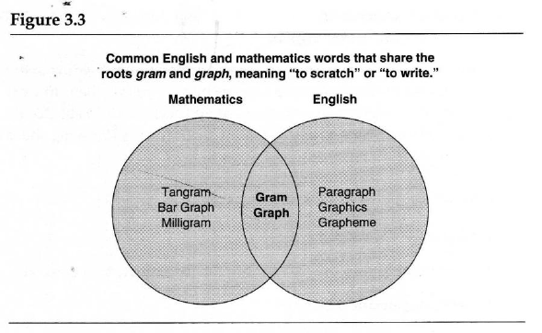Math Prefixes:

bi | co | contra | equi | kilo
mono  rect | multi  semi | octa  tri | peri | quad

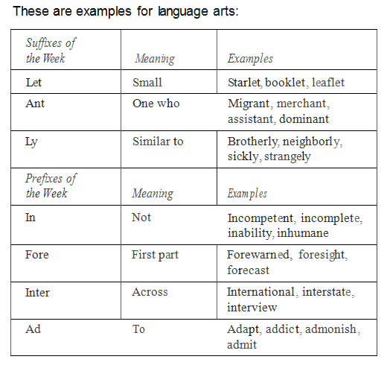

Other Strategies Students Like to Use to Remember Words

Students like to use props. They like sticky tabs, Post-it notes, color markers, color dots, pens in several colors. They underline, highlight, box, circle, and write over new words. They underline with red the words that are the hardest; in yellow those they "kinda know"; and in green for those they already know.

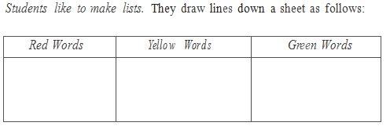

Students like to work in pairs. To study a word they can either

  - Draw a cartoon using the word.
  - Design a creative way of representing the word.
  - Invent a mnemonic device to remember the word, such as a brief chant, rhyme, rap; joke, or even a Shakespearean iambic pentameter stanza.
  - Try to come up with as many synonyms for that word as possible.
  - Try to come up with as many antonyms for that word as possible.
  - Using all the words of the week, develop word games to play with other pairs.
  - Put words on cards with clues and challenge another pair of students.
  - Act the word out, or invent a motion to match the meaning, play charades with another pair.

Students love the word polysemous. They like to

  - Locate polysemous words in the text.
  - Go to the dictionary and find the multiple meanings of a word.
  - Challenge other teams with multiple meanings.
  - Invent a rap, chant, song, or a silly sentence using the multiple meanings, such as "The trunk with the elephant's trunk was found under the tree trunk and put in the car trunk al,211g with our swimming trunks."

Students like word searches/puzzles in teams. They like to

    - Find compound words, prefixes, suffixes in the text.
    - Breakup compound words and put together other words with
each part .
    - Use affixes such as gram, photo, graph, geo, phon, cycl, deci, scribe, vid, dyna and say in which subject they would be most likely to find that word.
    - List as many key words as they can remember from a chapter.
    - Challenge other teams to find several key words in a text, while
timing them .
    - Writing meaningful sentences (where the meaning is embed­ ded in the sentence) with words such as metaphor, for example: "Juan used a metaphor, a figure of speech, a sensory symbol, a most poetic way to tell Rosa he liked her when he said, 'You are a true rose."'

Working in pairs or teams of four makes learning fun and easy. Teachers like cooperative learning because they can monitor student learning much more easily. They can also conduct instructional conversations where students are guided to use the words they are learning, to discuss the topics they are studying, and to ask the teacher questions. Ways of organizing effective cooperative learning strategies that are specific to literacy development are further described in the next chapters.

How teachers like teaching words

There are ongoing activities designed to review words from previous lessons and help students listen for and use words outside of the class. Games are used to promote word use outside of class. Some activities can be designed to conduct with parents, older siblings, or for self-review, such as additional passages with the vocabulary learned that day. A classroom where there is semantic awareness has word walls that contain pictures of the words and labels or words organized by category. Student writing is posted, as well as posters containing reminders about grammar, syntax, and cognates. This chapter ends with a sample of "Teachers' Favorite Vocabulary Activities" we have collected in middle and high schools.

For Preteaching Vocabulary Before Reading

- List of technical words and everyday words are on the board.

- The teacher reads the words and gives quick definitions or explanations.

- Students say each word 3 times.

- The teacher reads aloud from the beginning of a new chapter or
text and asks students to visualize as she reads.

- Teacher emphasizes words as she reads, adding meaning to the
context.

- Students raise their hands each time they hear a new word.

- Students later work with words in various ways-writing sen­ tences, doing word puzzles, and writing summaries using as many new words as possible.

For Reviewing and Preteaching Words In Ongoing Reading

l. List of technical words and everyday words are on board from
yesterday.

- The teacher reads aloud from the beginning of a new chapter or text while students circle unknown technical words and under­ line everyday words.

- Teacher asks each team to give words from both categories as
he lists them on the board next to yesterday's words.

- Teacher says the word and gives a quick definition or example.
Students later work with words in a variety of ways.

For Reviewing Words With Numbered Heads Together

l. Students number off from 1 to 4.

- The teacher gives them a typed list of Tier 1, 2, and 3 words learned that week.

- Students must make sure everyone in the team know s the def­ inition, spelling, pronunciation, and how to use the words in a sentence.

- The teacher calls a number; the corresponding student is given a word and must answer for the team by saying it, spelling it, and using it in a sentence.

For Reviewing Words With Expert Jigsaw

l. Teacher gives each team a different set of laminated index cards with vocabulary words on one side and definitions on the other.

  - Students must make sure everyone in the team knows the def­
inition, spelling, pronunciation, and how to use it in a sentence.

  - Then, every 3 minutes two students go to a different table to teach and test those students.

For Reviewing words Before a Test

1. Students form a “Conga Line” or a “Tea Party Line” or “Texas Two-Step Line.’

- They bring lists of words and stand in front of a partner.

- With partner number one, they practice using words in sen­
tences or reviewing definitions before their test.

- When the music starts, they move to the next partner to prac­ tice more words.

- They continue changing partners and studying words for about 5 minutes.

For Reviewing Words With Vocabulary Roundtable

- Each team uses only one paper and one pencil.

- In round-robin style, each student writes one word learned that week, passes the paper to the right, the next student writes a different one, and so on, until teacher calls time. The team with the most words wins.

For Reviewing Words With Vocabulary Write-Around

1. Each student has one paper and writes a sentence using a word, passes the paper to the right. Reads the one pa ssed from the left, and adds a sentence with a new word.

For Reviewing With vocabulary Amazing Race

- Students are given a polysemous word to look up in the dictio­
nary and thesaurus.

- They must write 3 or more sentences using a different meaning.

- Once the teacher approves the sentences, they are given an envelope with scrambled definitions and words to put together.

4. Once the teacher approves that the definition, they have another task using 5 words correctly (e.g., compose a song; make a poster).

For Identifying Words to Reteach

1. A parking lot poster is placed close to the classroom door with a Post-it pad next to the poster.

- Students write unfamiliar words they encounter during class or in homework assignments on the Post-its and place them on the parking lot.

- Teacher discusses each word at the end of the period or begins the next day explaining the words and concepts.

Summary

Vocabulary must be explicitly taught to ELLs if they are to catch up to grade-level standards.

Vocabulary instruction must also be part of a comprehensive
language and literacy program across the content areas.

It is important to preselect words to teach before, during, and after reading to focus on the most important concepts from the standards, and basic knowledge that will make a difference in the students' test results.

Explicit instruction on word knowledge consisting of phonemic, phonological, and morphemic awareness, decoding, and under­ standing of the multiple meanings of the words occurs in the con­ text of teaching reading and using content texts.

Language development is accelerated through reading, dis­ cussing, writing about texts-after Tier 1, 2,_and 3 vocabulary has been explicitly taught. ·--..

